Please complete the current document according to the instructions on this page and the Standard Operating Procedure(SOP) Document Templates [MTG-DOC-001].

Template Name
MTG-TPL-040 Supplementary Material

Version History
Version | Author | Date | Notes | Supported
1.0.0 | Cristina Jácome | Feb 7, 2025 | Initial Version

Instructions
[...] Indicates a field to fill in with relevant information. Any instructions regarding the field will be written within the field brackets.
{...} Indicates an instruction to consider in the following content blocks. Proceed according to such instruction, then delete the {...} blocks before finalizing the document.
Delete this page before finalizing the document.

Supplementary Material

Contents
Study Group 3
Data Source(s) 3
Data Source [...] 3
Data Source [...] 3
Supplementary Table(s) 4
Table S[...] 4
Supplementary Figure(s) 5
Figure S[...] 5
References 6

Study Group
{In real-world evidence studies, the manuscript may refer to the collective group as a consortium. For instance, it might designate the authors as “The XYZ Study Group,” with detailed information about the participating members included in the Supplementary Material. When listing members, order them by contribution; if contributions are similar, opt for alphabetical order. While it is acceptable to list names only, providing both names and affiliations is preferred for clarity. Remove this section if not applicable.}
[...]

Data Source(s)
{In the Supplementary Material we have the opportunity to better describe the data source(s) used in our RWE manuscript.
Example of an introductory sentence: The study processed data from xx local health units/health institutions. A detailed description of the respective data source(s) is provided below.}

Data Source [...]
{For each data source describe:
- Geographic Location(s): where the data is collected.
- Time periods: periods of recruitment, exposure, follow-up and data collection
- Health Care System Context: overall structure (e.g., universal coverage); care models (types and number of care providers); sectors (e.g., primary care, inpatient settings, specialist care, nursing homes, …)
- Population Size and Characteristics: proportion of the included population
- Payment structures (e.g., capitation, fee-for-service).
- Missing data components}

Data Source [...]

Supplementary Table(s)

Table S[...]
{Add a table caption before the table.
Arrange variables in a logical order (e.g., as presented in Methods section).
Mention units of measurement
Explain any abbreviations in footnotes.
Only horizontal lines are allowed.
Standardize decimal cases.}

Example:
Table S1
Baseline cohort characteristics (n=544).
Patient Characteristics | Total  n=544 | Male  n=380 | Female  n=164
Female, n (%) | 164 (30.1) | - | -
Age (years) | 65 (50-67) | 63 (49-65) | 68 (55-71)
LDL-C (mg/dL) | 116 (71-120) | 116 (70-125) | 113 (65-130)
LDL-C Controlled, n (%) | 191 (35.1) | 134 (35.3) | 57 (34.8)
Data shown as P50 (P25-P75) unless otherwise indicated. Abbreviations: LDL-C, Low density lipoprotein - cholesterol.

Supplementary Figure(s)

Figure S[...]
{Add a caption after the figure.
Mention units of measurement
Explain any abbreviations in footnotes.
Standardize decimal cases.}
Example:

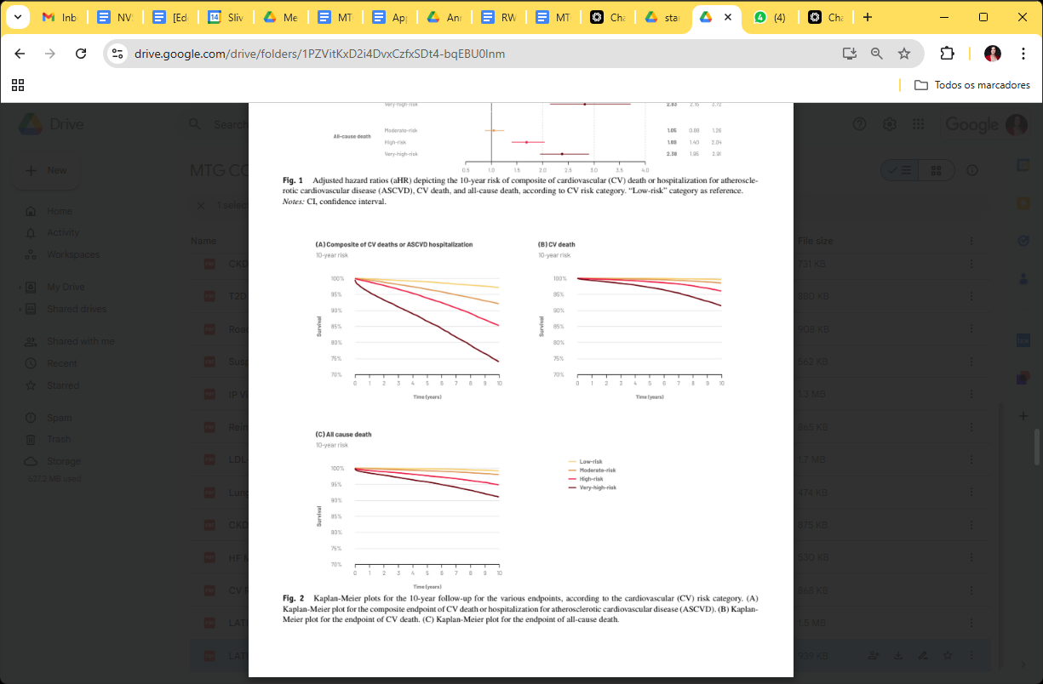
Kaplan-Meier plots for the 10-year follow-up for the various endpoints, according to the cardiovascular (CV) risk category. (A) Kaplan-Meier plot for the composite endpoint of CV death or hospitalization for atherosclerotic cardiovascular disease (ASCVD). (B) Kaplan-Meier plot for the endpoint of CV death. (C) Kaplan-Meier plot for the endpoint of all-cause death.

References
{Ensure that reference formatting aligns with the chosen citation style of the journal. Confirm that references to digital reports/websites include the URLs along with the date of access. Check for any omissions regarding the volume number or page range in scientific papers, as these are crucial for proper citation.}

